Group: Delta
Names:
Blake, Milo
Fox, Shane
Mastromonaco, Caleb
Schaefer, Andrew
Thomas, Jennifer
Date: 07/08/2021
Module: 10.2

Milestone #1:

Case Study: Bacchus Winery
Stan and Davis Bacchus inherited their winery from their father, George, three years ago upon his retirement. While they both appreciate all the hard work their father put into the business, they are anxious to incorporate new business methods to help them improve their products and customer service.
When they started running the winery, the owners decided to keep all existing personnel in place, hoping to effect minimum change during the turnover. Presently they employ Janet Collins, who is in charge of all finances and payroll; Roz Murphy, who heads up the marketing department, she has one assistant, Bob Ulrich, working for her; Henry Doyle, who manages the production line, as well as 20 employees; and Maria Costanza, who is in charge of distribution.
Bacchus Winery grows the grapes needed to make a Merlot, a Cabernet, a Chablis, and a Chardonnay. They have been receiving their supplies; bottles and corks from one supplier, labels and boxes from another, and vats and tubing from a third supplier, each of which ships the components every month or so. Stan and Davis are responsible for keeping track of the supply inventory and would like to find a more efficient method of keeping track and ordering supplies, perhaps over the internet. Maria, who is responsible for distribution, would like their distributors to be able to order online, and to be able to track shipments.
Stan and Davis know the yearly ‘snapshot’ of the business is due in a few weeks, and need the information to determine the state of the inventory, the distribution and the employees. They need information on…
- Are all suppliers delivering on time? Is there a large gap between expected delivery and actual delivery? A month by month report should show problem areas.
- The wine distribution, are all wines selling as they thought? Is one wine not selling? Which distributor carries which wine?
- Employee time. During the last four quarters, how many hours did each employee work?
Business rules:
A supplier can have many supplies but a supply can only have one supplier.
A delivery can have many supplies and supplies can have different delivers.

A distributor can have several wines, but a wine can only have one distributor.
A distribution can have several wines and wines can have different delivers.
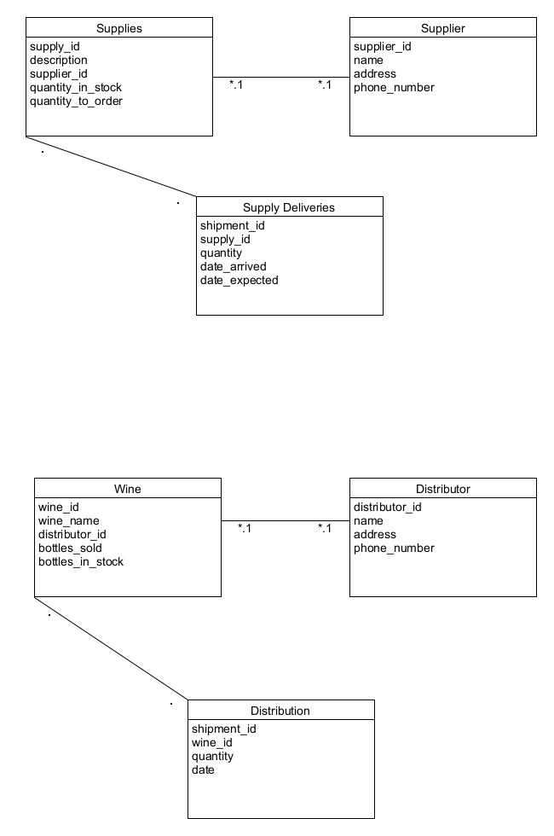
Tables:

Supplies table:
supply_id | description | supplier_id | quantity_in_stock | quantity_to_order

supplier table:
supplier_id | Name | Address | Phone_number

Supply Deliveries table:
shipment_id | supply_id | Quantity | date_arrived | expected_arrival_date

wine table:
wine_id | name | distributor_id | bottles_sold | bottles_in_stock

Distributor Table:
distributor_id | Name | Address | Phone_number

Distribution table:
shipment_id | wine_id | quantity | date

Employee tables:
Employee_id | first_name | Last_name | hours_worked_Q_1 | hours_worked_Q_2 | hours_worked_Q_3 | hours_worked_Q_4
1

